
Business / Technical Brief

Design Specification

Domino-INT028 – Return to Vendor Integration from Fusion to WMS
29th May 2024, Version 1a.
Copyright © 2024, Oracle and/or its affiliates
Confidential – Oracle Restricted

Document Control

Change History
Date | Author | Version | Description
29-May-2024 | Amit Sharma | 1a | Initial Version
25-June-2024 | Harshada Ingole | 1b | Technical Design Updates

Reviewed By
Date | reviewer | role
25-June-2024 | Rakesh | Technical Lead

Table of contents
Document Control 2
Change History 2
Reviewed By 2
Introduction 4
Purpose 4
Overview and Scope 4
Business Objectives 5
Process Overview 5
Mapping 5
Pre-Conditions 5
Risk Matrix 6
Other Integrations Design Dependency 6
Frequency 6
Business Use Case: 7
Open Items 7
Technical Section 8
Glossary 8
Document References 8
Sample Data & Mapping Template 8
Frequency 8
Assumptions 9
High Level Approach 9
Pre-Requisites 10
Integration Analysis - XxPublishItemsErpToWms 10
Integration Components 10
Required Connections 11
Integration Outline 11
Main Code Flow Snippet 21
Global Fault 23
Migration Steps 25
Unit Testing 25
Open and Closed Issues 25

Introduction

Purpose
This Design Specification documents the detailed design for RTV Interface from Fusion Inventory Management to Oracle Cloud WMS.
This document describes the functional design of the list of attributes which need to be interfaced from Fusion to Cloud WMS through Oracle Integrated Cloud Service (OIC) to create RTV Outbound Order in WMS. The design document also covers the event attribute mappings from Fusion to Oracle Cloud WMS Functional Columns.

Overview and Scope
Overview
All RTV transactions will be recorded first in Fusion. The fields required by Oracle Cloud WMS to carry out the transaction as an Outbound Order shall be queried from Fusion and passed on to OIC wherein the data shall be transformed and mapped to the Sales Order Shipment Outbound Integration from Fusion to Oracle Cloud WMS.
This transformed data shall then be sent to WMS to process the RTV transaction as a sales order shipment. The Sales order will be created within WMS with an order type specifically configured for (and as) “RTV”. The sales order would then be waved, picked, packed, and shipped within Oracle Cloud WMS.
However, the Shipment Confirmation for such Sales Orders with Order Type “Return to Vendor” will not be sent back to Fusion.
Return to Vendor (RTV) transactions will be primarily recorded in Fusion but sent to WMS to adjust the inventory in WMS so, that both the systems are in perfect synchronization. Returns would be created using a 1-way communication from Fusion to Cloud WMS.

Business Purpose
Domino has a requirement to record Return to Vendor transactions for received goods in certain cases such as a receipt of a damaged product, receipt of wrong product, material returns from lineside locations etc. The current Oracle Cloud WMS product does not support out of the box Return to Vendor functionality; hence a custom solution is required to capture & communicate RTV transactions between Fusion and Oracle Cloud WMS. Therefore, this requirement will be catered within Fusion and sent to Oracle Cloud WMS.
Scope
The scope of this document is limited to functional design of the interface which includes event to pull Return to Vendor transactions from Fusion, map the fields to Sales Order Shipment Outbound Interface within OIC and interface the RTV transaction to WMS as a Sales Order.

Functional Overview

The RTV order in WMS should include the following details at minimum:
- Order Number
- Order Type
- Item Number
- Quantity
- Ship to Address (Supplier Address)
- Ship Date
- Item Quantity
- Inventory Org ??

Business Objectives:

Returns to vendor (due to multiple reasons like sales returns, purchase returns owning to Quality Issues etc) need to be returned back to supplier. This will be done in fusion using RTV transaction (unreference / referenced PO return) and would result in shipment to supplier and item stock decrementing in inventory org. To keep the inventory in fusion and WMS in sync the interface will send return data to WMS to decrement the stock.

Requirement ID | Category | Short description
INT028 | Return to vendor from Fusion to WMS | This interface will publish RTV order for Warehouse Management System (WMS).

Process Overview
- The material may need to be returned to supplier due to quality issues or returns from production. These are largely bulk returns to supplier without reference to PO.
- The return material is shipped to Supplier and it interfaces RTV transaction in WMS to decrement the Stock.

Mapping

Pre-Conditions
- By representing the WMS as an inventory organization, virtual tracking, and visibility of inventory at the WMS location is available to users in real time.
- Order type should be configured in WMS.
- The Fusion Inventory Management Organization structure should be mapped with WMS Facility structure. i.e. Inventory organizations of Fusion Inventory should be mapped with WMS Facilities. Sub inventory of Fusion Inventory Management should be mapped with WMS Lock Codes.
- The domain for which the ASN is sent should be created in WMS. Domain in case of WMS would be Business Unit and Inventory Organization in Fusion.
- Items in WMS should be active and in sync with Fusion Product Hub.

Risk Matrix
Risk | Impact  (1 to 5) | Probability  (1 to 5) | Mitigation

Other Integrations Design Dependency

Name | Dependency | comments
WMS Items (INT001) |  | Items should be interfaced to WMS from Fusion PDH

Frequency
Responsiveness | Frequency | Comments
XxScmRTVErpToWMS | ESS Job runs every 5 minutes

Business Use Case:
- Trigger RTV from Fusion for a serial controlled item
- Trigger RTV from Fusion for a lot-controlled item
- Trigger RTV from Fusion for a non-inventory item

Open Items
This section is used to summarize any open items related to the design.
No. | open item |  |  | data required/Owner | status | impact if not closed
001
002
003
004
005
006
007

Technical Overview

Scope
The objective of this document is to provide with a Technical Specification for Outbound Integration to Create Return from Enterprise Resource Planning (ERP) to Warehouse Management System (WMS).

Glossary
Annotation | Definition
ERP | Enterprise Resource Planning
WSDL | Web Services Description Language
WMS | Warehouse Management System
OIC | Oracle integration cloud

Document References
Ref No | Name | File location

Sample Data & Mapping Template

Description | File
Data Mapping Template for ERP to WMS
Sample Request XML Payload

Assumptions
- Mapping between WMS and ERP should be in place for this integration to work effectively.
- For end-to-end flow, connections of the Integration should be in place.
- In case of any success/error in the integration, a notification email will be sent to the mail list configured in the OIC lookup.

High Level Approach
- ” XxScmRTVErpToWMS” integration is event based.
- If transaction type is Return to Vendor, then RTV order will be created in WMS.
- WMS API will be invoked and Fusion fields will be mapped with WMS API xml.

High Level Flow Diagram
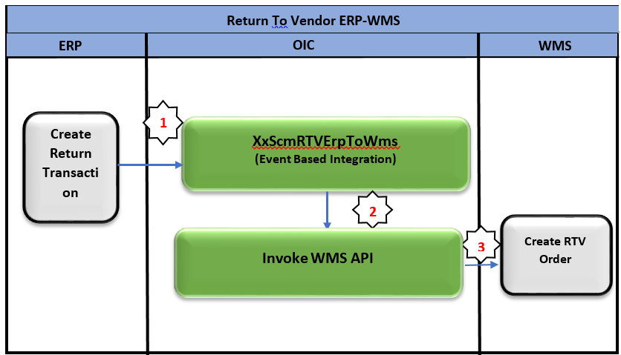

Pre-Requisites
- Send Email Integration “XxCommonNotificationHandler” should be deployed in the OIC.
- Lookup “XXDominoCommonLookup” should be present with all the required details regarding success/error email notify flag, success and error notify ToEmail Address in OIC.
- Lookup “XxDominoConstantLookup” should be present with all the required details regarding success and error notify FromEmail Address in OIC.
- “XxGetLookupVariable” Integration should be deployed in the OIC to fetch local variables.

Integration Analysis – XxScmRTVErpToWMS
This is Create Return Transaction event based integration from ERP to WMS. It will create Return to Vendor Order in WMS to pick, pack and ship.

Integration Components
Below are the required components for this integration.

Integration Name | Integration Pattern | Package Name | Lookup Name
XxScmRTVErpToWMS | App Driven Orchestration |  | XXDominoCommonLookup,  XxDominoConstantLookup

Required Connections
Connection Name | Connection Type | Connection Role
XxDominoWMSConnection | REST | Trigger and invoke
XxDominoGtmConnection | Logistics | Trigger and invoke
XxAtbDb | Database | Trigger and invoke

Integration Outline
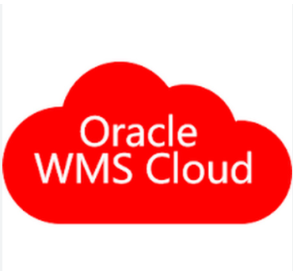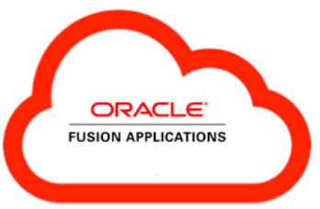
Create Return Transaction Event will be received in OIC
OIC App Driven
Integration
XxScmRTVErpToWms
Invoke WMS API

The following section explains the step - by- step process of integration:
XxScmRTVErpToWms
- Trigger_RTVTransaction: Create Return Transaction Event will be triggered.
- Stitch_gvar: Assigned variable to.
Variable name | Data type | Value
IntegrationCode | String | dvm:lookupValue('XXDominoCommonLookup', 'IntegrationName',$self/ns1:metadata/ns1:integration/ns1:name, 'IntegrationCode', '')  This value will be fetched from OIC lookup “XXDominoConstantLookup”.
Var_CompanyCode | String | dvm:lookupValue('XXDominoWmsCompanyLookup', 'Organization', 'DE_M05', 'WMS_Company_Code', '')  This value will be fetched from OIC lookup ”XXDominoWmsCompanyLookup”.
EmailFrom | String | dvm:lookupValue('XxDominoConstantLookup', 'ID', 'FromEmailId', 'Value', '')  This value will be fetched from OIC lookup ““XXDominoConstantLookup” which is used to send notification email from OIC service.
Var_InstanceName | String | dvm:lookupValue('XxDominoConstantLookup', 'ID', 'InstanceName', 'Value', '')  This value will be fetched from OIC lookup “XxDominoConstantLookup”

- Assign_gvar: Assign Variables
Variable name | Data type | Value
IntegrationCode | String | dvm:lookupValue('XXDominoCommonLookup', 'IntegrationName',$self/ns1:metadata/ns1:integration/ns1:name, 'IntegrationCode', '')  This value will be fetched from OIC lookup “XXDominoConstantLookup”.
Var_CompanyCode | String | dvm:lookupValue('XXDominoWmsCompanyLookup', 'Organization', 'DE_M05', 'WMS_Company_Code', '')  This value will be fetched from OIC lookup ”XXDominoWmsCompanyLookup”.
EmailFrom | String | dvm:lookupValue('XxDominoConstantLookup', 'ID', 'FromEmailId', 'Value', '')  This value will be fetched from OIC lookup ““XXDominoConstantLookup” which is used to send notification email from OIC service.
Var_InstanceName | String | dvm:lookupValue('XxDominoConstantLookup', 'ID', 'InstanceName', 'Value', '')  This value will be fetched from OIC lookup “XxDominoConstantLookup”
- ForEachTrxType:
Repeating element
/ns22:onEvent/inp1:findTransactionResponse/inp1:result
Current element name *
CurrentTrxType
SwitchCase: If TransactionType is Return To Vendor then the below flow will be executed.
- InvokeVendorDetailsBIPReport: It’s a call to BIP report to get Vendor details.
- AssigbFileRefrernce: Report output will be decoded to base64.
- StageFile: It will read the BIP output in .csv format.
- Stage_writelgfdataXml: It will convert the data in xml format.
- InvokeWMSRestAPI: It will invoke WMS init_stage_interface API.
- ErrorHandling: If API response is success, the success email will be triggered; else the error notification will be triggered with reason.

ERP Request and Response Schemas:

WMS Request
WMS Response

Sample WMS Transmission Response:
Transmission Response | Response Message
SUCCESS | <HTTPHeaders/>  <ConnectivityProperties  xmlns="http://xmlns.oracle.com/cloud/adapter/connectivityproperties/REST/trigger_RTVTransaction">  <RestAPI>  <http.response.status>200</http.response.status>  <http.response.reason>OK</http.response.reason>  <http.target.endpoint.uri>https://tb10.wms.ocs.oraclecloud.com/domino_test/wms/api/init_stage_interface/</htt  p.target.endpoint.uri>  </RestAPI>  </ConnectivityProperties>  </executeResponse>
ERROR | http://www.w3.org/Protocols/rfc2616/rfc2616-sec10.html#sec10.4.1  Bad Request  400  <![CDATA[InboundJaxrsResponse{context=ClientResponse{method=POST,  uri=https://tb10.wms.ocs.oraclecloud.com/domino_test/wms/api/init_stage_interface/, status=400, reason=Bad  Request}}]]>  <![CDATA[<?xml version="1.0" encoding="utf-8"?>  <root>  <success>False</success>  <response>  <message>Processing failed for entity movement_request and file group 2023-04-  18T09:35:22.895Z_20230418053524195</message>  <errors>  <error>  <key>191</key>  <msg>Sequence Number Mismatch for item alternate code EPP003436</msg>  </error>  </errors>  </response>  </root>.  A 400 Bad Request Error indicates that the target service is unable (or refuses) to process the request sent by the  client (Oracle Integration Cloud), due to an issue that is perceived by the server to be a client problem. You can  trace the cURL representation of the request sent to the target service from the Oracle Integration Cloud server  logs. Try invoking the target service using cURL. It may also be that one of the intermediaries (proxy, LBR) could be  returning this code. ]]>

- Notify: Once the data is posted into GTM side and all the operations in Integration are completed normal then success email notification will be sent to respective team through “XxCommonNotificationHandler”.
With map activity, process will map the below values to common error handler Integration.
Request Parameters | Values
IntegrationCode | $self/nsmpr0:metadata/nsmpr0:integration/nsmpr0:identifier
IntegrationID | $self/nsmpr0:metadata/nsmpr0:integration/nsmpr0:name
InstanceID | $self/nsmpr0:metadata/nsmpr0:runtime/nsmpr0:instanceId
EmailFrom | $EmailFrom
EmailTo | $GetLocalVariable/nsmpr1:GETResponse/nsmpr1:components.schemas.response-wrapper/ns38:SuccessNotify
EmailSub | Shipment From WMS to
Logging | 'Y'
Local integration “XxCommonNotificationHandler” will be triggered based on above mentioned values in map activity and will send Notification email to concern team.

Main Flow Code Snippet
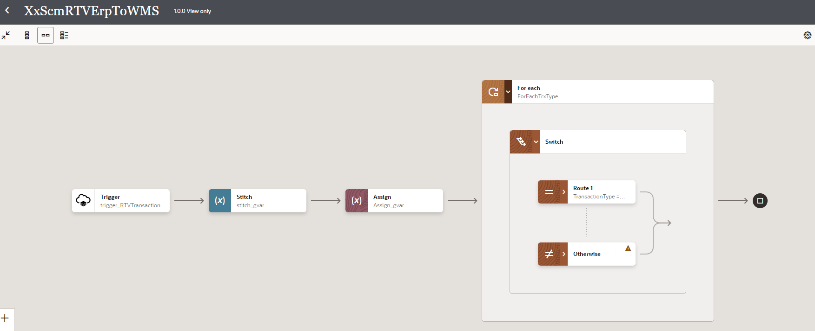
4b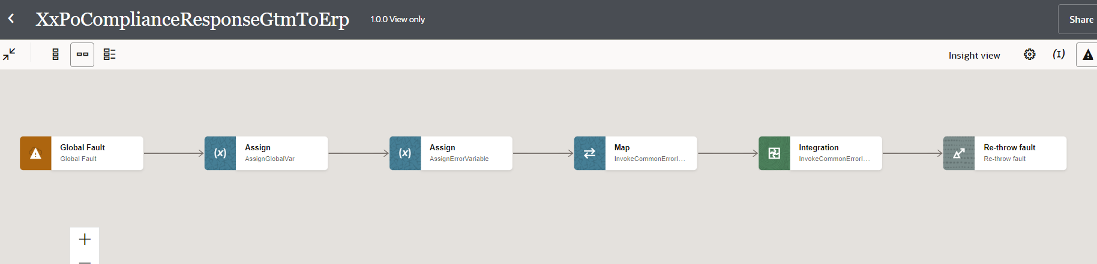
4a
2
3
1

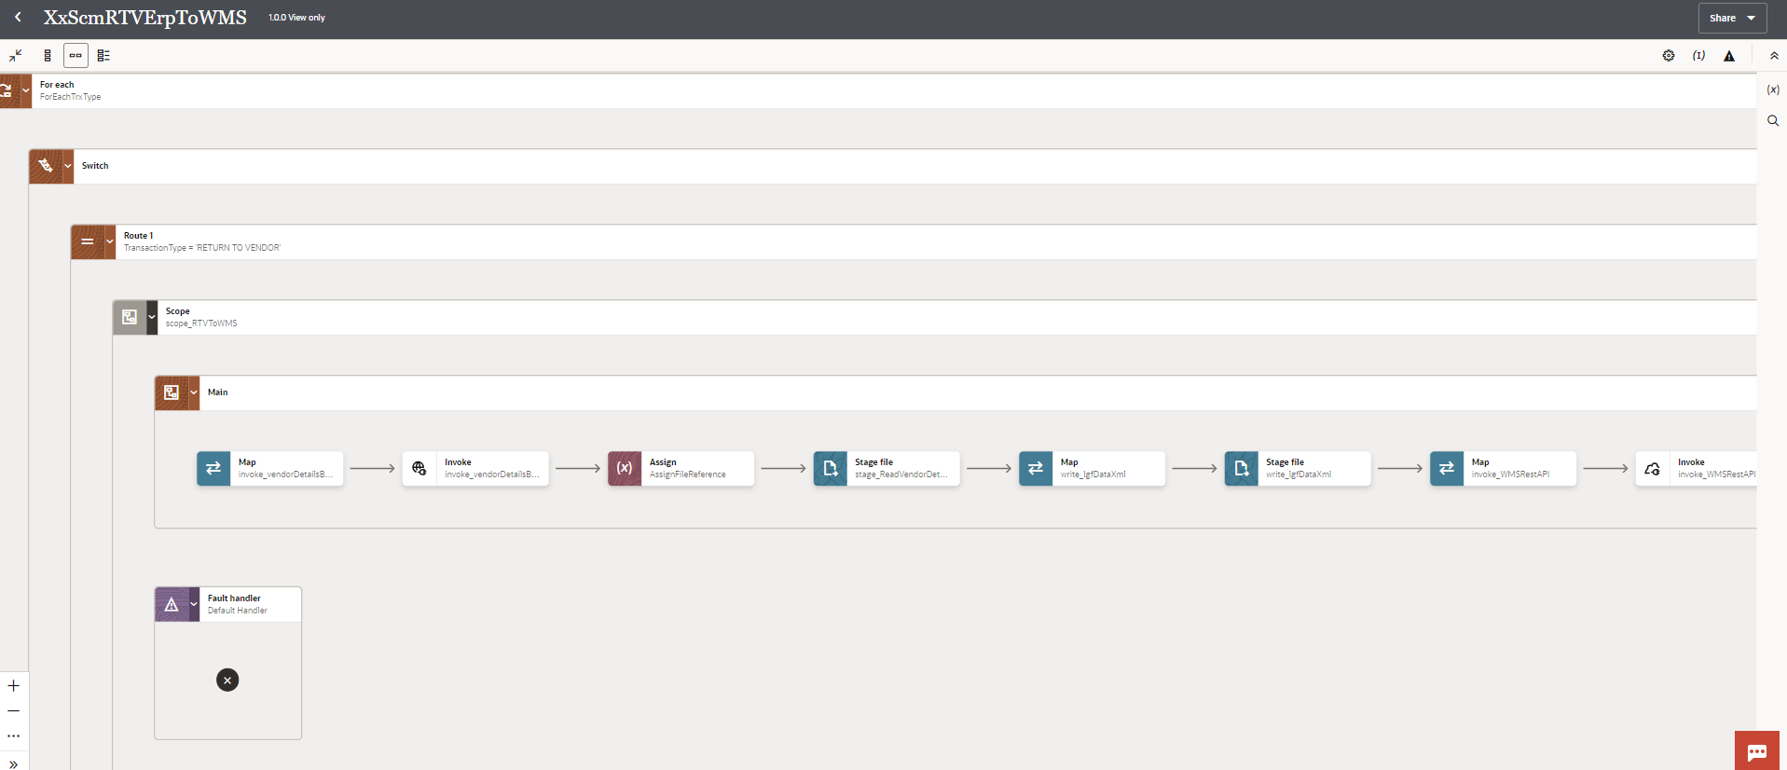
9
8
7
6
5

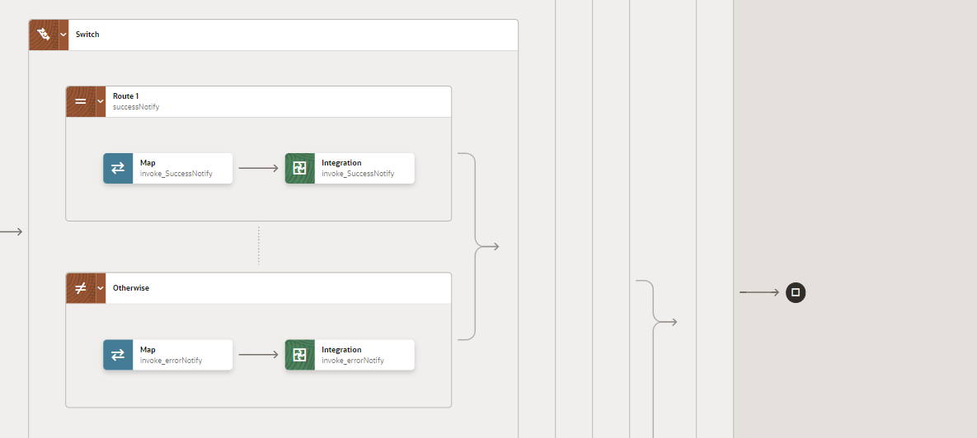
10a
10b

Figure: Main flow code snippet

Global Fault
- The global fault handler is responsible for the whole execution scope and process the exceptions occurred in the individual stages.
- InvokeErrorHandler:
  - The global fault handler will invoke the local integration “XxCommonNotificationHandler” which captures the error occurred at any step in overall integration flow and notify it over the email.
  - Using the map activity “Map to InvokeCommonErrorHandler”, process would map the below values required for XxCommonNotificationHandler.

Request Parameters | Values
IntegrationCode | $IntegrationCode
IntegrationID | dvm:lookupValue ("XXDominoCommonLookup", "IntegrationName", $self/nsmpr1:metadata/nsmpr1:integration/nsmpr1:name, "RiceID", "" )
InstanceId | $self/nsmpr2:metadata/nsmpr2:runtime/nsmpr2:instanceId
ErrorCode | $GlobalFaultObject/nsmpr0:fault/nsmpr0:errorCode
ErrMsg | $GlobalFaultObject/nsmpr0:fault/nsmpr0:reason
EmailFrom | $ var_EmailFrom
EmailTo | dvm:lookupValue ("XXDominoCommonLookup", "IntegrationName", $self/nsmpr1:metadata/nsmpr1:integration/nsmpr1:name, "FailureNotify", "" )

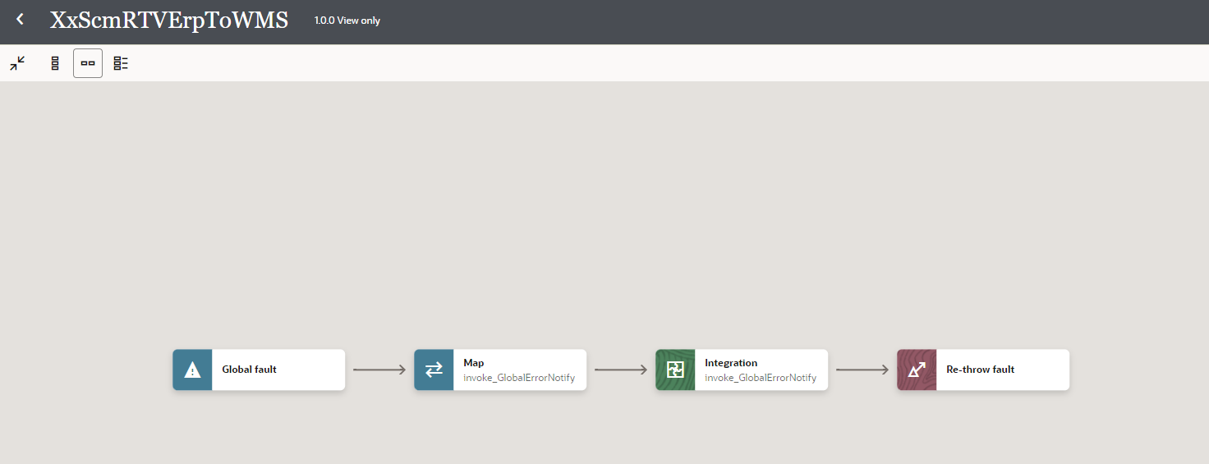
3
2
1
Figure: Global Fault Code Snippet

Migration Steps
2

- Import “'XXRTVERPTOWMS.iar” in OIC environment.
- Update the OIC Connections with Password, details as per the Environment.
- Validate the "XxCommonNotificationHandler", which is deployed in OIC.
- Configure the Connection with Dev Instance URL, Instance Name (whenever updated) which is present in Domino Constant lookup maintained in OIC.
- Complete the OIC integration configuration and activate OIC service.

Unit Testing
2
4
3

Please refer the attached file for the Unit Test cases performed for this integration.

Open and Closed Issues
This section is used to summarise any open and closed questions relating to Error Handler

ID | Topic | Description | Status | Owner
1
2.

